5.59: Consider a point a distance x from the top of the rope. The forces acting in this point are T up and 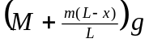 downwards. Newton’s Second Law becomes 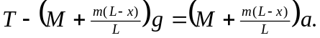 Since 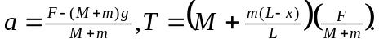. At 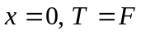, and at 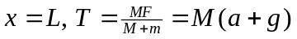 as expected.

